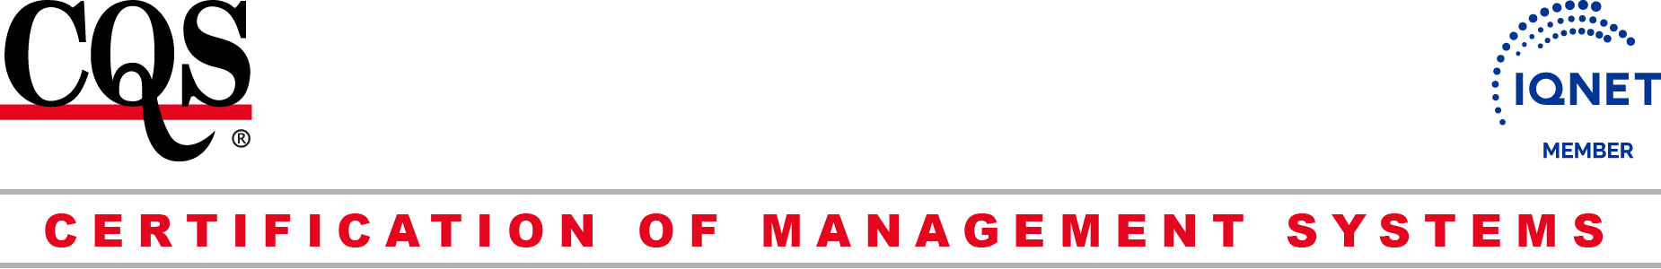

CQS
Prosecká 412/74, 190 00 Praha 9 - Prosek
IČ: 69346305 DIČ: CZ69346305
tel.: +420 286 019 533, +420 286 019 534
e-mail: cqs@cqs.cz
http://www.cqs.cz

Questionnaire „ISO 9001 / ISO 13485“

EN ISO 9001
EN ISO 13485 please tick

Applicant:

BACKGROUND OF THE IMPLEMENTATION OF SYSTEM

 | question / answer |  |  |  |  | ¹⁾ Delete, if inappropriate
 | In accordance with the production program / ​​services provided (subject to certification), please implement your processes for product / service:
Realization processes that are subject to certification:
ISO 9001:
-
-
-

ISO 13485:
-
-
-

Processes that are used for external resources (outsourcing, co-operation):
-
-
-

(Please list in Appendix, if more processes)
Place of certification (headquarters, branches, localities):

Identification of organizations covered by certification (headquarters and) / place: |  |  | Number of employees: | Number of shifts: | Scope (Activities):
Headquarters
Plant
Plant
Plant
Plant
 |  | Next, add as needed
 | Is a single management system in place throughout the organization? |  |  |  |  | YES | NO
 | According to the defined processes provide the legislation in relation to your products / services:
-
-
-

 | Are there any special processes applied in the product implementation? If there are, name them (or include their list in Appendix).  -  -  - |  |  |  |  | YES | NO
 | Do you perform the following activities?
 | - design and development, |  |  |  |  | YES | NO
 | - purchasing, |  |  |  |  | YES | NO
 | - traceability, |  |  |  |  | YES | NO
 | - customer’s property, |  |  |  |  | YES | NO
 | - measuring and monitoring equipment control |  |  |  |  | YES | NO
 | Since when has the QMS been implemented in the organization?
 | Who has implemented the QMS in your company?
 | Date you anticipate to obtain the certificate:
 | Indicate by what other standards have been certified management system:
 | Name of Certification Body:
 | Are the management systems integrated? |  |  |  |  | YES | NO
 | An integrated documentation set, including work instructions to a good level of development, as appropriate
 | Management Reviews that consider the overall business strategy and plan
 | An integrated approach to internal audits
 | An integrated approach to policy and objectives
 | An integrated approach to systems processes
 | An integrated approach to improvement mechanisms, (corrective and preventive action; measurement and continual Improvement)
 | Integrated management support and responsibilities
Questionnaire compiled by: , , ……………….  (name, position, signature) |  |  |  |  |  | DATE:

review CB CQS: not to be completed by applicant

Předpoklady k posuzování QMS dle ČSN EN ISO 9001 / ČSN EN ISO 13485 jsou – nejsou splněny:

Provede člen CQS:

NACE pro ISO 9001:
Hlavní TO a TO pro ISO 13485:

Přezkoumal: …………………………….

