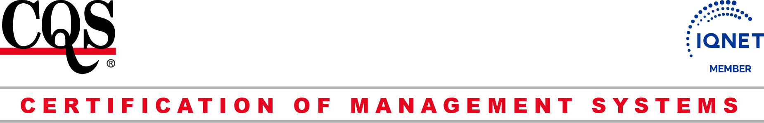

CQS
Prosecká 412/74, 190 00 Praha 9 - Prosek
IČ: 69346305 DIČ: CZ69346305
tel.: +420 286 019 533, +420 286 019 534
e-mail: cqs@cqs.cz
http://www.cqs.cz

APPLICATION FOR SYSTEM MANAGEMENT CERTIFICATION
Applicant’s Name: |  | Identification Number:
 |  | VAT number:
Address of Applicant |  | Beneficiary‘s Bank:
 |  | Beneficiary’s Account Number:
Statutory Representative (name/position):

Number of employees: | Number of shifts:
Contact person for communication with CQS and for sending of documents from audits:
Name: Position: E-mail:
Tel.: Mobil:
Scope:

Standard for certification (tick):
EN ISO 9001:2015 + complete the questionnaire 9001/13485
EN ISO 14001:2015 + complete the questionnaire 14001
EN ISO 45001:2018 + complete the questionnaire 45001
ISO/IEC 27001 :2022 + the questionnaire 27001 (CB fills with cooperation with applicant)
HACCP + complete the questionnaire 22000/HACCP
EN ISO 22000 :2018 + complete the questionnaire 22000/HACCP
EN ISO 3834-2 :2021 + complete the questionnaire 3834-2
EN ISO 50001 :2018 + complete the questionnaire 50001
Declaration: The applicant undertakes to meet the certification requirements and agrees with certification process rules and procedures, and after concluding the agreement to secure the CQS representatives with an access to all places related to assuring the management system of the required production program and to provide all the required information and written documents.
The Applicant declares that the details stated in the Application hereof are complete and correct.

,
Place and Date of Application Stamp + Signature

